Second Grade Scholar’s News

ELA News!!!
Our students have been very busy reading “Breakout Lab”. Ask them who is Max and what was the problem in the book? We have also been working on le, s,z,or, ar, er, ir, ur and or patterns in phonics. The class has been writing topic sentences, supporting details and a conclusion using various texts.

Math News!!!
Math, math and more math. We are off to a great start with our Math Expressions series. We have completed Unit 1 and you will receive those results next week. We are starting Unit 2 which consists of more word problems and now 2 digit addition. We are learning a method called New Ten and New Hundred Above. Please ask your son/daughter to show you how this is done.

Science News!!!
In science, we have been learning how environments change over time. Nature, animals and plants can all change an environment. We also discussed the ways people harm environments and ways that people can help our environment.

2nd Grade College Door Decorations
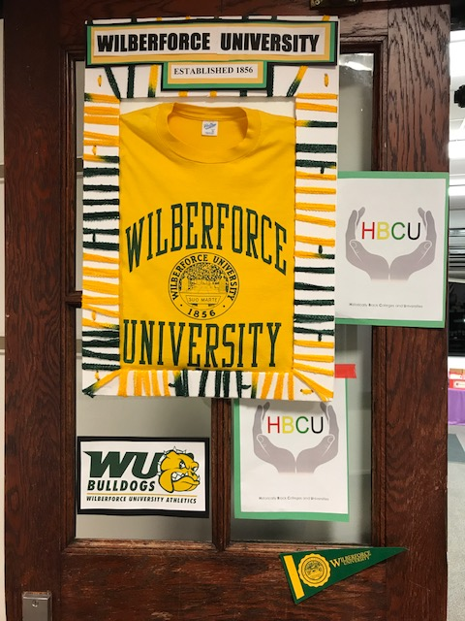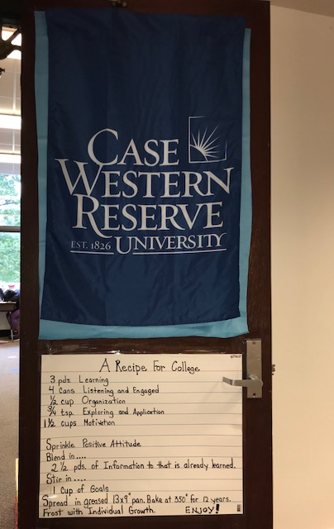
Moultrie Gobieski
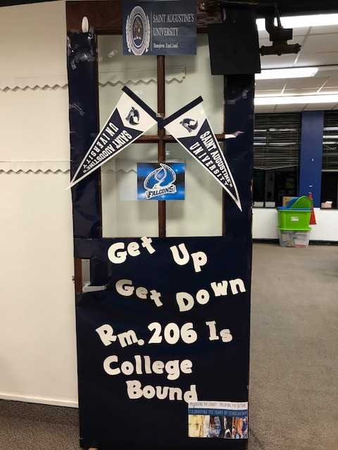
Windham

