Fourth Grade October’s Newsletter

AVID:
We are continuing to work on our organizational skills. Students are implementing the use of their AVID binders as well as their planners and sections constantly. We have also spent time cleaning out binders when it is needed. PLEASE REPLENISH PENCILS!
We are becoming masters at two column notes! Ask your scholar what those are. We are now working on layering our two column notes using the STAR method.
We only have six students who have turned in their $20 activity fee so far. We need the money to go on further field trips. Please send the $20 in ASAP.

ELA:
We have been busy! We finished Unit #1 in Ready Gen, wrote two different types of informative essays – a five paragraph essay and an infographic, took the unit assessment and started Unit #2. In addition, as entire grade, we are working on opinion writing. Through both types of writing, we are working diligently on writing introductions clearly, organizing our thoughts into complete paragraphs, and using transitional words. I am so proud of everyone’s hard work and progress. Ask your scholar about our car race track and how they can earn blue ribbons!

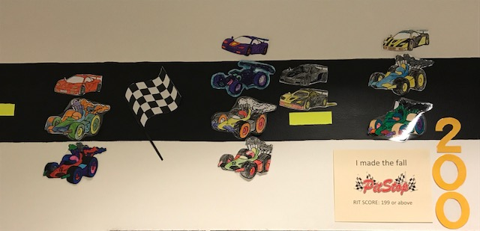

Math:
Where did October go? We finished Unit #1 and took our assessment. Students were given their individual results. We are well into the next unit which involves two digit multiplication. We are learning how to multiply using area models and with square units. Remember we all need to work on our math facts!

Social Studies:
Last month we focused on science. This month the focus is social studies. We are learning to analyze primary and secondary sources. Ask your scholar what the difference is and which is more reliable. In addition, we are investigating our state – quiz us on Ohio fact. What is our state bird? Finally, we are working on timelines. The scholars are doing a fantastic job.

