Our 5th grade scholars are working hard and it has been a very busy 6 weeks of school. It has gone by so quickly. It seem like yesterday we were outside observing the very exciting the eclipse. Now, we are putting our noses to the grindstone and expanding our learning.
In math, our focus is fractions. We are comparing, making equivalent, and working toward add and subtracting with unlike denominators. We are also analyzing a number every week to build our number sense. During many of our class days our scholars might be playing "Flip and Roll" to practice our fraction skills. Activities coming up will include the bag of 16 and gum chewing day.

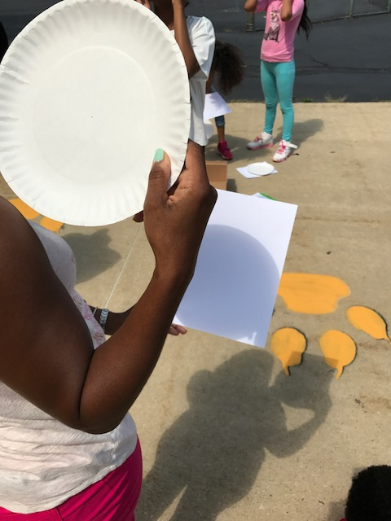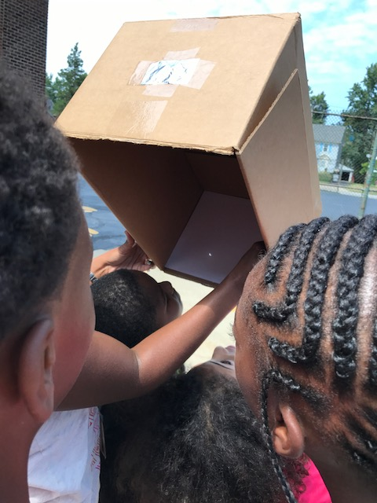

Noble scholars explored ecosystems and physical and behavioral adaptations. The big idea is that organisms perform a variety of roles within an ecosystem. Plants and animals have specific functions that contribute to the health of the environment, this is called their niche. Scholars have also learned several AVID strategies to increase learning. They have reviewed the STAR note taking system (Set-up notes, Take notes, Add to notes, Review notes), 2-column and 3-column notes, and specific collaboration strategies. Ensure your scholar reviews their notes from all classes each night. Continue to check Infinite Campus for graded assignments.

During this first trimester our Noble Scholars have worked hard on utilizing the writing process to produce imaginative Narrative Writings for Unit 1 Module A of ReadyGen. Students have created characters that had an secret identify which helped them better understand how to incorporate descriptive details, with engaging dialogue; while developing the plot, rising actions and climax for their Narrative stories.
Next, students read Night of the Spadefoot Toad by Bill Harley. This was a story about a boy following his passion for nature while learning to find his voice through a series of events that kept the reader both engaged and wondering what would happen next!
Students also read “Shells” by Cynthia Rylant and an excerpt from the story “Hatchet” by Gary Paul.
The usage of these texts helped support our students’ completion of their Performance-Based Assessment writing assignment; that required them to write a story about a character that cares about his or her surroundings. In this writing students had to describe the actions the character took to show their understanding of the environment.
Now as we continue with the reading theme around environments, students have the opportunity to begin reading the follow-up text for Unit 1 Module B. This includes “Washed Up!” by Payal Kapadia and Rain Forest: Food Chains by Heidi Moore. Both texts give students the opportunity to learn more about characters interacting with their environments and how environments support people. Which will lend it’s support to students upcoming Performance-Based Assessment writing assignment, that ask students to write an informative essay that describes one of the environments they read about in Unit 1.
Please remember all students can go onto the CHUH homepage to access the Pearson Website thru the Elementary Online Resources. Here students can read the material ahead of time as well as review the text for a 2nd time to keep the information fresh and new.
Happy Reading and Writing from Noble’s 5th Grade-ELA

