Kindergarten October Newsletter
This month, we talked about the Four Seasons in our Science lessons. The lessons talked about how trees change and what happens to them. So we knew Patterson's Fruit Farm was the PERFECT place for us to make connections with our learning. While at the farm, we learned how apples made it from the orchard to the store, how they get a bath, and get shined up so we pick just the right one for us. We toured the orchards and the huge refrigerator they store the apples in before they go to market. The students sampled an apple and apple cider as a product made on the farm. We had a great time exploring the corn maze, the corn box, the forest play area and riding on an open air wagon to our destination.
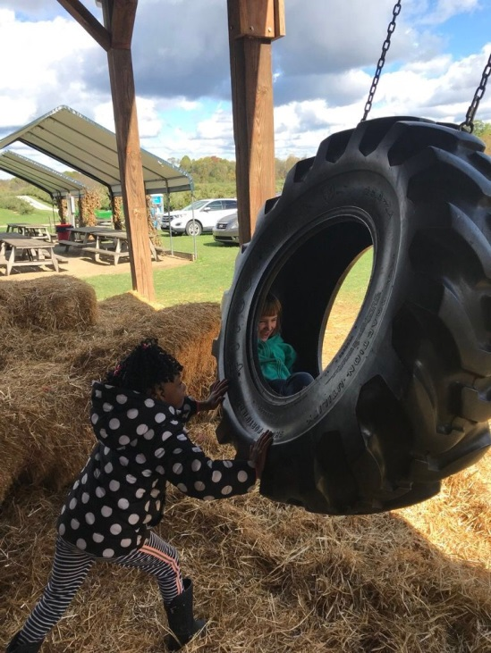
We learned about Johnny Appleseed and how he helped spread seeds
throughout the land and provide food for incoming families.
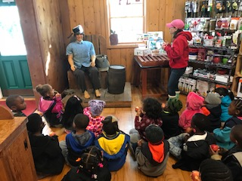
Thank You! to all the families that helped make our trip possible!
We had a great time!

