Physical Education with Mr. Wright

In Gym, this past month, K-2 students worked on
movement skills such as hopping, skipping, jumping, and leaping.

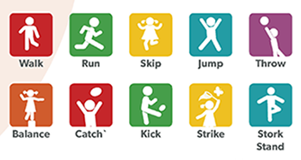

We played a variety of games to work on these skills.
One week we even had a combined class with Ms. Murphey’s Spanish class
learning movement terms and colors in Spanish.

Grades 3-5 worked on throwing and catching a football, punting a ball,
and played a tagging and evading game.

Additionally, every PE class always begins
with students warming up, stretching, doing push-ups and crunches,
and doing a 3 minute jog.
Please remind your child to always wear sneakers for Gym. For some activities,
I have to have them sit out because their shoes may not be safe for activities.

Thanks
&

