Physical Education with Mr. Wright

In Gym, this past month, all grades have participated in a
Soccer unit, working on kicking, dribbling, passing, and trapping.
We played a variety of games to work on these skills.
Younger students focused on skill acquisition while the older students
applied these skills to game and game-like situations.
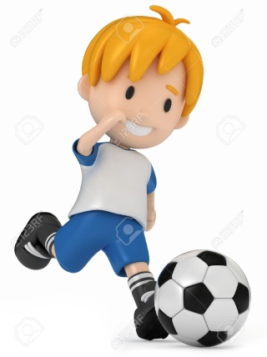
Additionally, every PE class always begins with students warming up,
stretching, doing push-ups and crunches, and doing a 3 minute jog.
Students have learned how important it is to run at a steady pace for this.
Please remind your child to always wear sneakers for Gym.
For some activities, I have to have them sit out because
their shoes may not be safe for activities.

Thanks
and

