Science Enrichment
Noble scientists are excited about beginning a new year in science lab. Pre-K and kindergarten scientists will be starting the Earth and Space unit by studying seasonal weather changes and learning to use a thermometer. First graders are studying living things and how living things grow up. Second grade scientists have learned how plants and animals become fossils and are excited about making their own fossils in lab. Scientists in third grade are working jointly with our Spanish and art enrichment teachers studying the life cycle and migration of monarch butterflies. Fourth and Fifth graders have begun researching ecosystems of the world. Their research will culminate with an informational report about a specific ecosystem and a model of a food web from that ecosystem or a model of the ecosystem showing animal and plant adaptations, respectively. Science enrichment is off to a great start and we are looking forward to an awesome year.

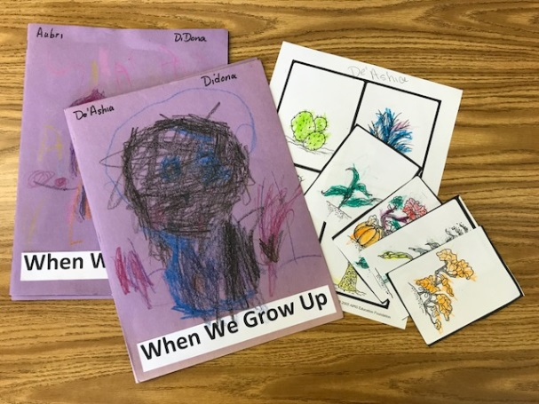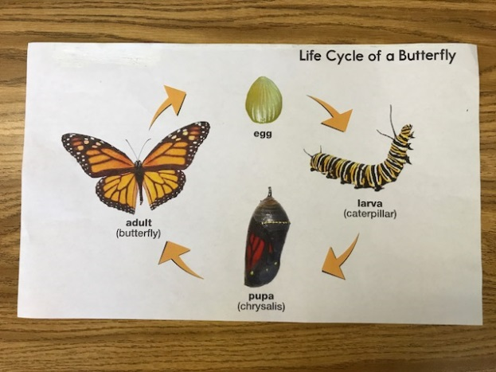

Jeannetta Russell
Science Enrichment

