Second Grade Scholar’s News

ELA News!!!
Our students have been building on the sound-spelling patterns and structural skills they developed in first grade. They have been practicing applying the phonics skills as they read phonetically controlled stories in their Superkids Reader. Some of the patterns we have been reinforcing in our daily routines are the following: sh, ch, tch, wh, th, le, ng, y, er, ir, ur, ar, s, and z. We have also been working on Superkid’s magazine and exploring the “What’s New” theme reading informational articles and building vocabulary. Our classes also have been learning how to write narratives and informational writing pieces.
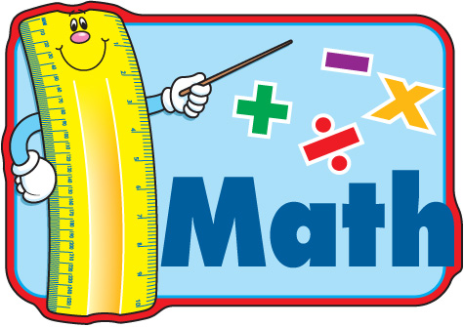
We are exploring all of the fundamentals in math. Fact fluency and now we are doing word problems. Please continue working with your son/daughter on their math facts daily. Reflex math is a fun and exciting way to learn their facts. If your son/daughter needs the log in information to get on Reflex Math at home please let me know and I will send it home with them.
Science News!!!!
We took a trip back to prehistoric time. In science, we have been learning all about fossils, how they are formed and how they help us learn about animals and plants that lived long ago. Our new science curriculum, allows students to receive interactive science lessons on the Smart Board and written activities in their science text books.

